## 

## Merchant

Demo date:   
Scoping start date: Jun 20, 2024

MSA Signature Date: Jun 26, 2024  
Onboarding Kick Off Date: Jul 1, 2024

[If Exists] Opt Out Date:  
Go Live Date: Feb 7, 2024

GTM POC: Nick  
Implementation POC: Ariel

ERP: QBO

Tax Integration: No Tax

### 

### Key people at Merchant

### Accountant: John Bowman, Chief Business Officer

### CFO: John Bowman, Chief Business Officer

### Customer service rep who is really involved: Bryan Champ, SVP of Sales

* Account Receivable POC: accounting@maybern.com
* Billing POC: accounting@maybern.com

### Company summary

Maybern is an enterprise software company designed to digitize investment management processes and simply fund operations. They provide a platform to Funds to streamline operations and reinvest their resources.

Goals (North star)

What is the merchant's goal? What pain are we solving? Why are they buying Tabs?

They need to use Tabs as the contract repository and escalate key terms across their client base. Currently doing this in Sheets/Google Drive. Will use tabs for all invoicing and reporting as well. Moving all finance operations for AR to Tabs.   
  
  
AE Notes

Any important relationship information  
  
1) What is Merchant Temperament?

John will be the main POC for Tabs. He is very easy to work with and this is a fellow primary PortCo. John was hired on a part time basis, but is practically working full time as their COO now.

2) Is there a key POC for the buyer/decision maker?

John Bowman, Chief Business Officer, and Bryan Champ, SVP of Sales

3) What are the Tabs features the key POC cares about?

Contract Storage, Invoicing, Reporting, Usage Data upload

### Billing model

* Info on how merchant bills
  + Quarterly with usage data (they take a Basis Point percentage on fund size
* How contract is broken up
  + Implementation fee, quarterly billing on usage data, multi year contracts
* One off things to know about merchant
  + One person finance team. Pull fund size usage data into a CSV that they will upload. Only have 5 contracts today

### Contract Processing Steps

1. Steps to process
   1. For new customers, both a parent and sub should be created
      1. Sub should be the fund name
      2. BTs should be created under the subcustomer
   2. Implementation fees
      1. Each fund should be its own BT for implementation
      2. Implementation is usually split into two 50% payments
      3. For example, if there are 4 funds, then there should be 8 total BTs for implementation, 50% of the amount for each
         1. First 4 are for effective date
         2. Second start on access start date.
            1. This is sometimes outlined in the contract, but if not then default to 6 months from effective date
   3. The rest are usage based BTs
      1. Usage can just follow the simple % stated in the contract instead of the 0.000025 per unit process we had before
2. Anything to ignore in contracts?
   1. Ignore the fund estimates, these are usage based terms that will be calculated quarterly
3. Sometimes there will be 2 documents for a customer: An MSA and an Order Form. MSA has payment terms and Order Form has billing terms
   1. He is going to try to put these into a single document when he can, but might not always be able to
4. Default Service Term
   1. If None Listed, Ops Default is 1 Year
5. Default Net Payment Terms
   1. If None, Ops Default is 0
6. Default Billing Frequency
   1. If None Listed, Ops Default is Quarterly (except for implementation, which is 2 invoices defaulted to 6 months apart if not specified)
7. How do we handle taxes as a line item?
   1. If None Listed, Ops Default is every tax line item becomes a BT
   2. They use AST

### Events Processing (if necessary)

* Usage based billing to calculate AUM fee for the funds
* This is called out in the contracts in a few ways:
  + In a chart that states the basis point

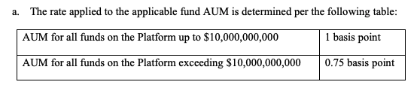

* + Or in a paragraph called out in a percentage

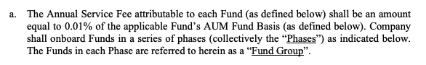

* + Sometimes, there might also be a tiered model (as in the image above). **Only process the first tier.** In the example above, 1 basis point is the one to process. Ignore .75 basis point
  + This structure is for the entire year, so 1 basis point per year.
* These BTs should look like this (example image below)
  + Title: Fund Service Fee for [Name of Fund]
  + Integration item: Fund Service Fee
  + Amount: percentage that is reflect of the basis point:
    - 1 basis point = 0.000025 (1 basis point/4 quarterly payments)
    - .75 basis point = 0.00001875 (.75 basis point/4 quarterly payments)
    - .5 basis point = 0.0000125 (.5 basis point/4 quarterly payments)
  + **\*\*\*BE SURE TO UNCHECK “IS BILLED IN ARREARS”**
    - These are NOT billed in arrears
  + Quarterly billing cadence
  + The first fund service fee should go out right after the 2nd implementation fee. Because usage bills are in arrears, the period start date for these terms should be 3 months prior to the 2nd implementation fee invoice date.
    - **For example:** If the 2nd implementation invoices go out 5/31, then the usage BTs should start from 3/1, so the first invoices for this term go out 6/1, a day after the 2nd implementation fee invoice.

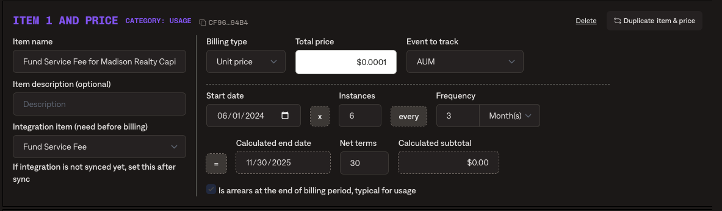

Integration Items Processing (if necessary)

* What are the instructions for assigning integration items?
  + Usage BTs: Fund Service Fee
  + Implementation: Implementation Fee Non-taxable (he will change to taxable one if need to charge tax)

Post Processing Communications (if necessary)

* Does Ops Team need to notify anyone on the team re: completion of processing batches in Implementation or Active phase?
  + No

### Customer Information

* Any important information on specifics customers of this merchant
  + Special memo’s certain invoices require
    - Will want Logo on invoices
  + Invoice changes due to merchant/customer relationship
  + Some customer will want the BTs separated into different invoices. Currently working on a way to solve this for them, no instructions for Ops on this right now

### Feature Requests

* FR 1
  + Escalation of renewals
  + Visibility into contract end data and important key dates
  + Medium urgency. They are contracted for a year with us

### Rewatch Calls

* June 5th, 2024 Intro Call
  + <https://tabs.rewatch.com/video/035bd5l6jtkqqic6-bryan-and-rebecca-schwartz-tabs-june-5-2024>
* June 26th, 2024 Proposal Review
  + <https://tabs.rewatch.com/video/hf04vcnv4a5627a0-maybern-tabs-proposal-sync-june-26-2024>